**Printing ALeP cards using MakePlayingCards**

**1. Using an archive of images**

* Download either **7z** or **zip** archive for **MakePlayingCards** (make sure that its name starts with **“MPC”**). Extract files from the archive. It contains two folders: **front** and **back**.
* Open [**http://www.makeplayingcards.com**](http://www.makeplayingcards.com) and click **Sign In**.

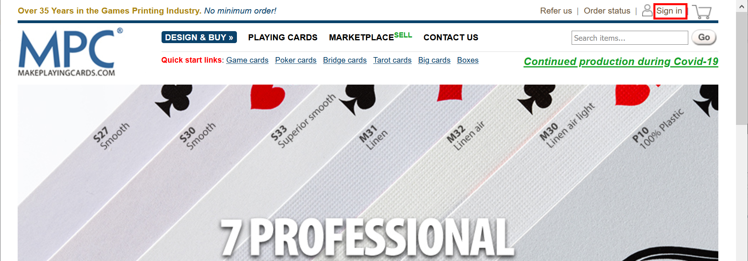

* If you already have an account, enter your credentials, and click **Login** button. Otherwise, choose whether you want to **register** or just login using **Facebook** or **Google**.

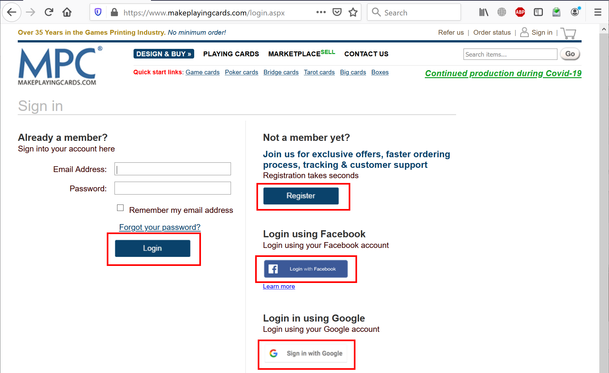

* Once you logged in, open this direct link:

[**https://www.makeplayingcards.com/design/custom-blank-card-traditional-size.html**](https://www.makeplayingcards.com/design/custom-blank-card-traditional-size.html).

* Choose **Card stock**: either **(S30) Standard Smooth** (slightly cheeper, moderate quality) or

**(S33) Superior Smooth** (highly recommended, slightly more expensive, higher quality).

* Choose correct **Size of deck**. For the Children of Eorl Deluxe it’s **Up to 198 cards**.
* Choose **Packaging**. We suggest **Plain white tuck box**, but you may consider other options as well.
* Leave the rest of dropdowns without changes:
* **Print type**: Full color print
* **Finish**: MPC game card finish
* **Wrapping**: Shrink-wrapped
* **Booklets**: None
* Click **start your design** button.

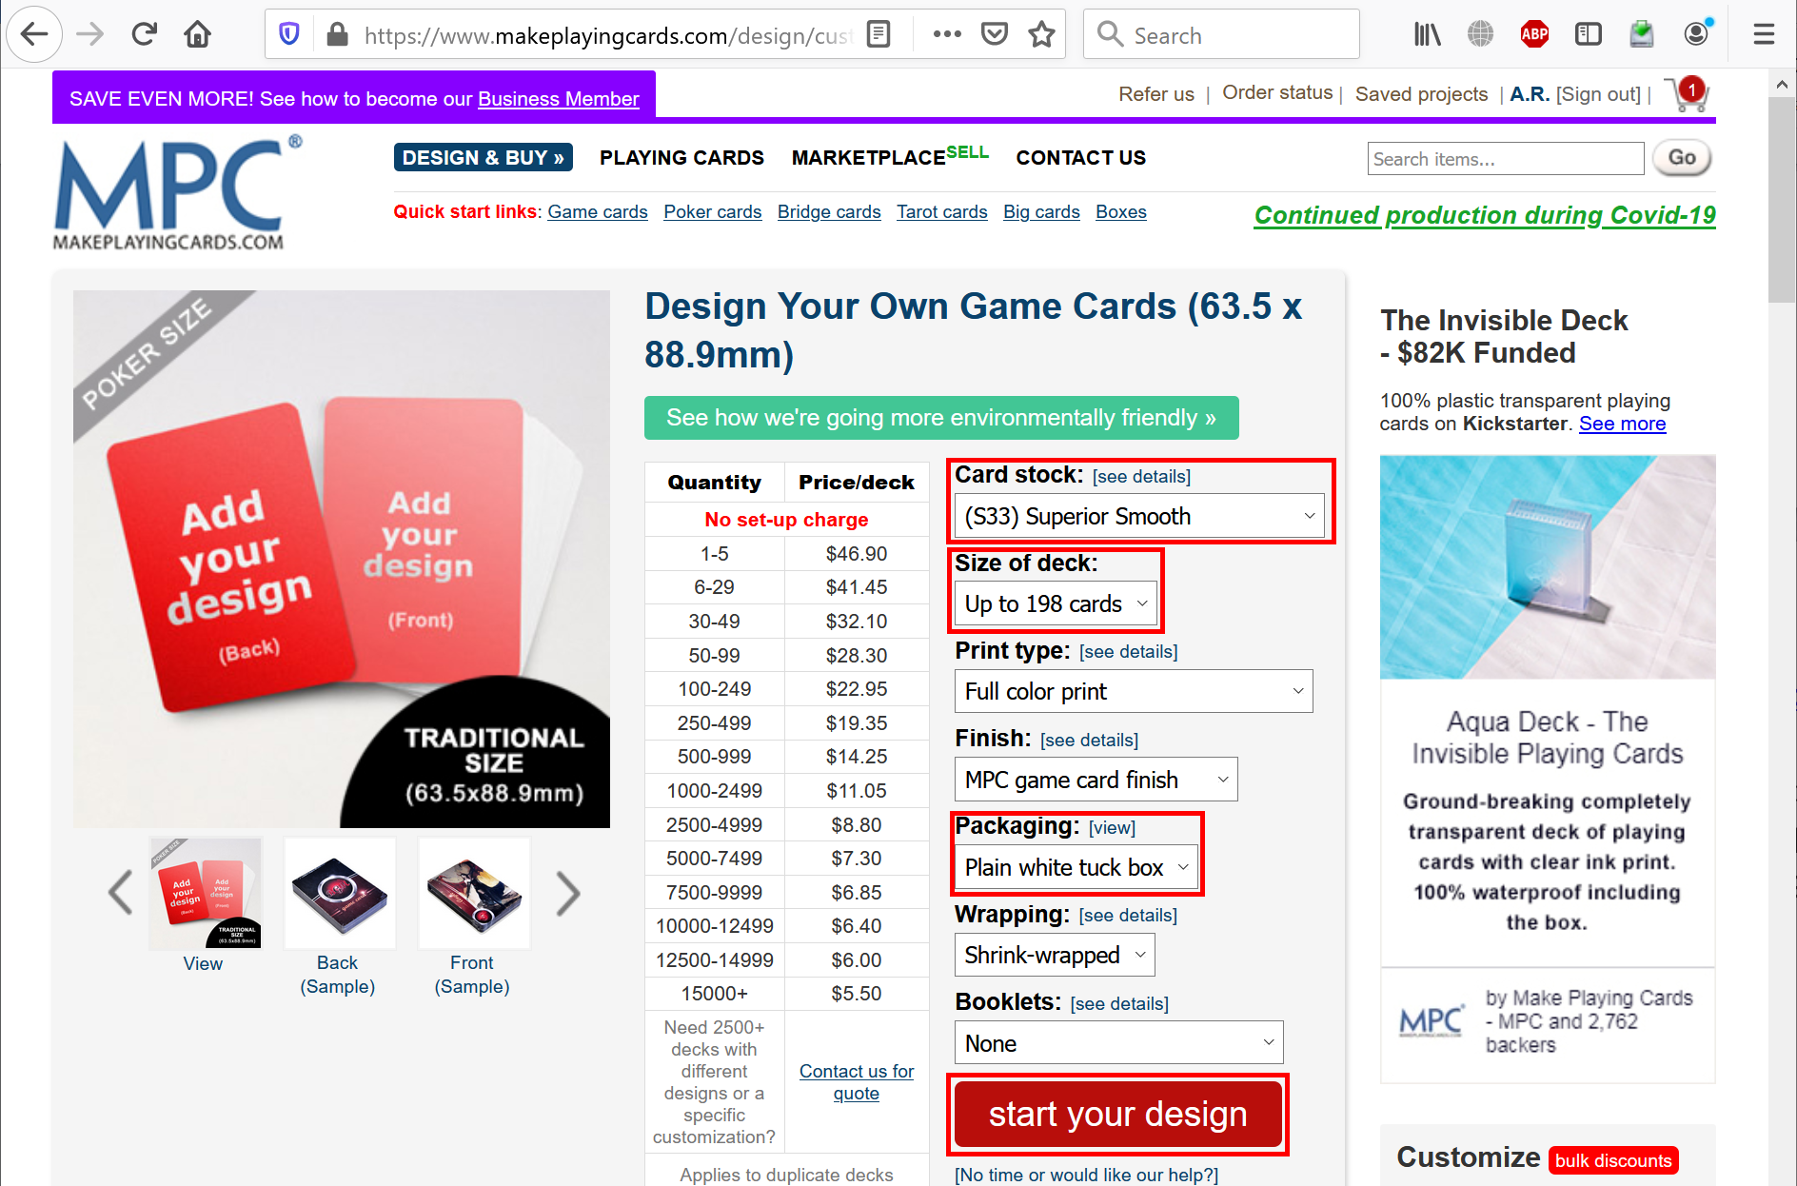

* Click **Different images** button.

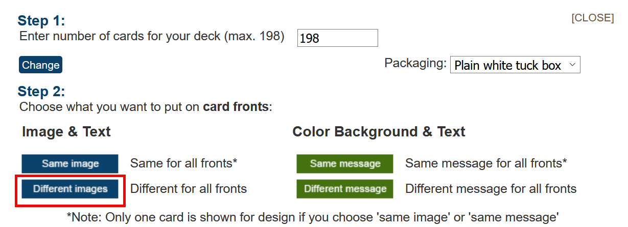

* Click **Upload images** button.

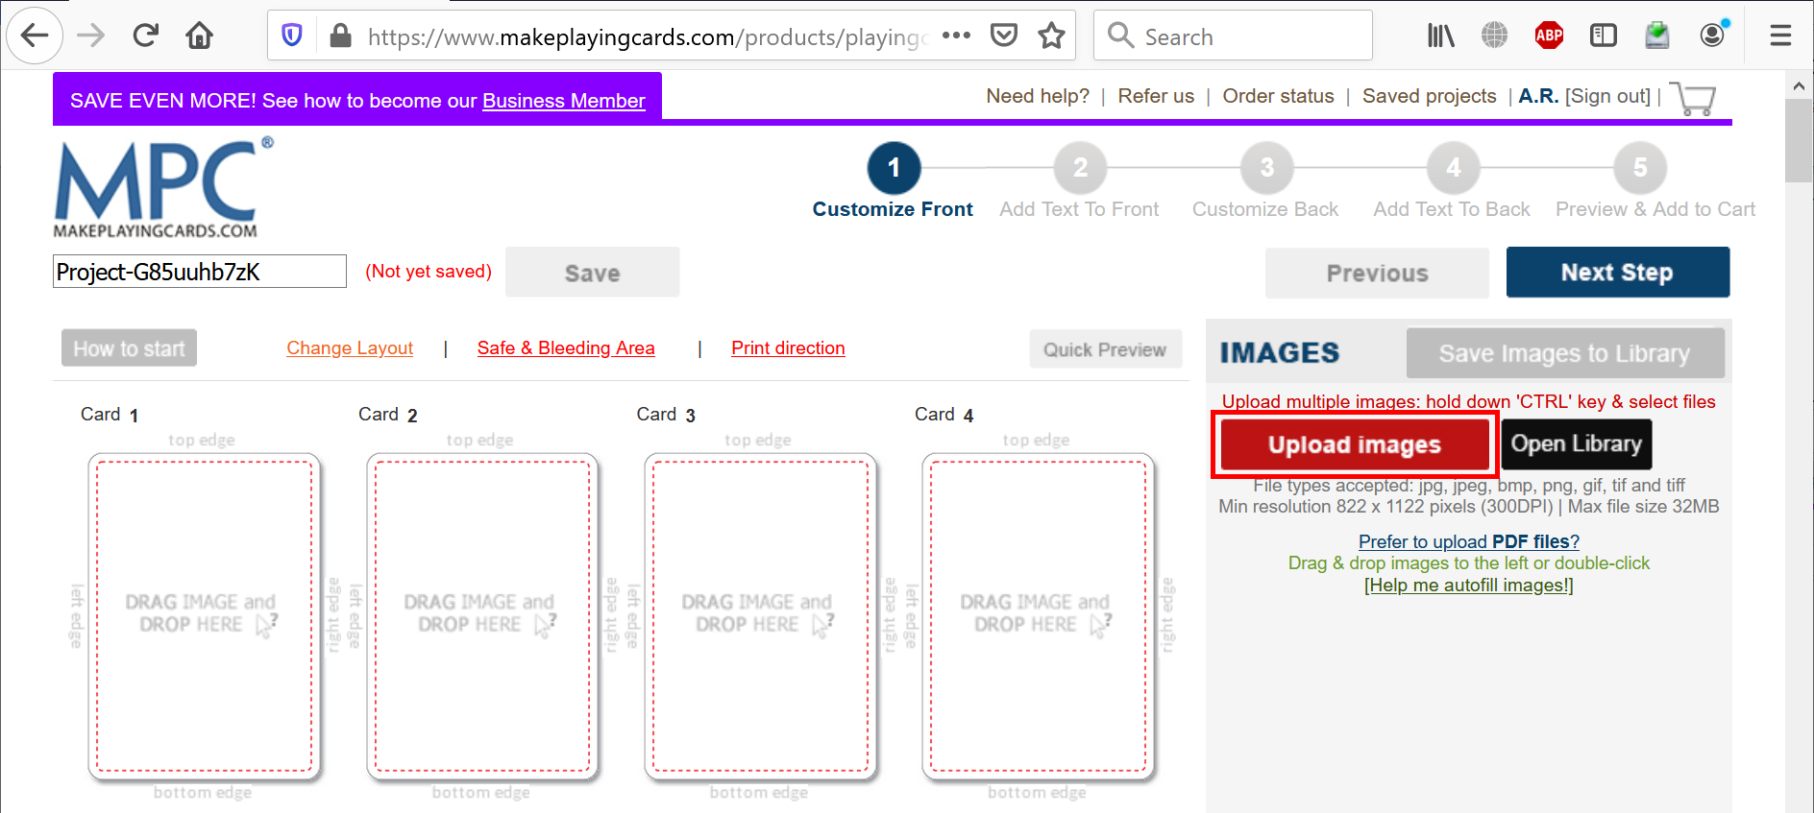

* Navigate to your **front** folder, select allimage files, and click **Open**. Wait until all images have been uploaded (depending on your Internet connection speed, this may take a while).
* Click **Help me autofill images!** and wait until all images have been placed into the area at the left.

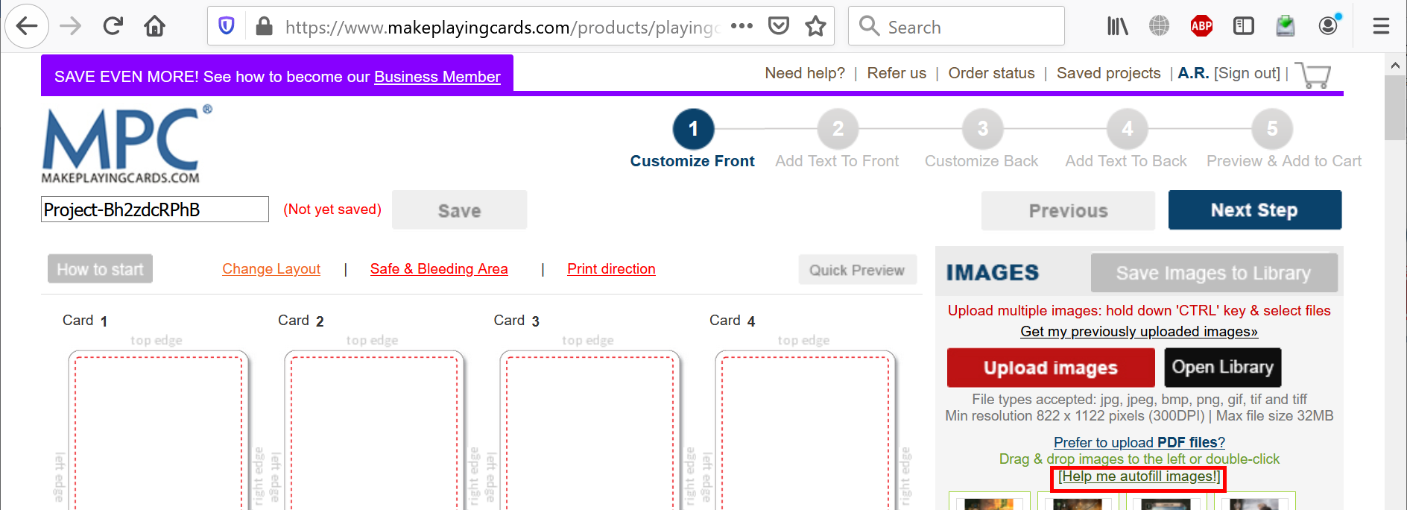

* Double-check that no blank cards left, then click **Next Step** button.

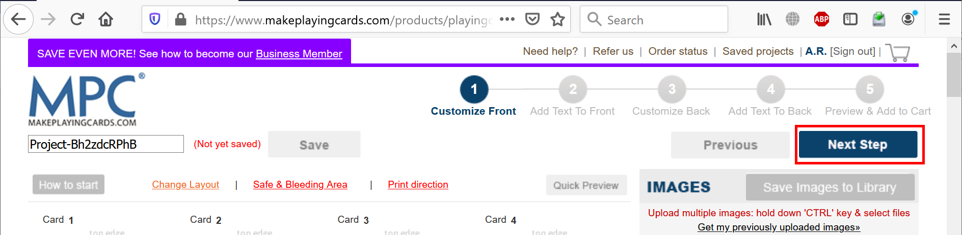

* Dismiss a help popup if any, don’t change anything and click **Next Step** button.

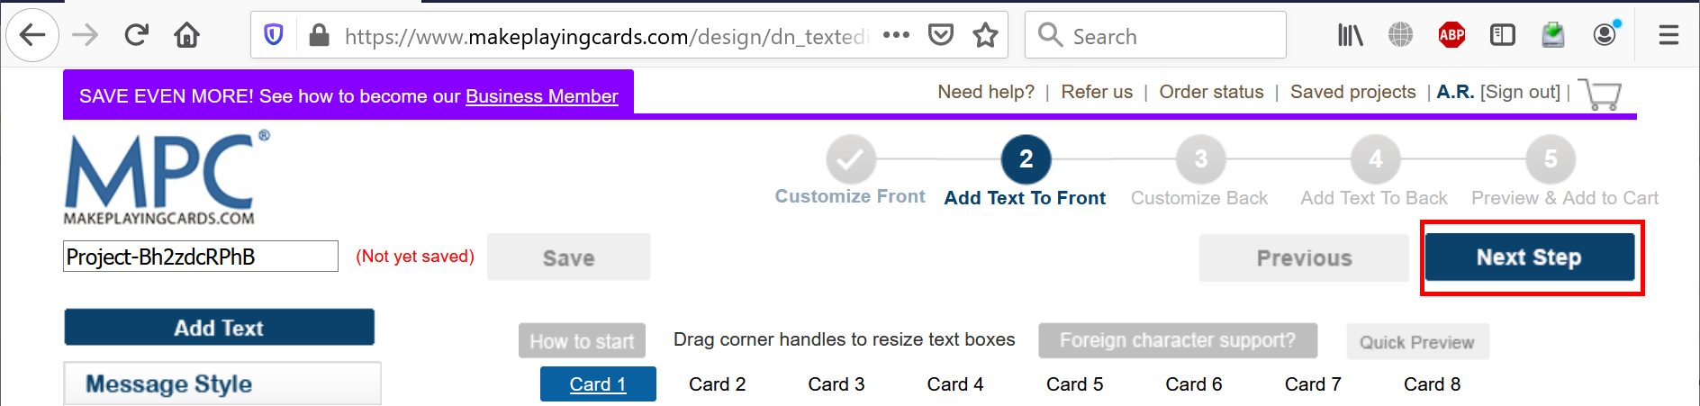

* Click **Different images** button.

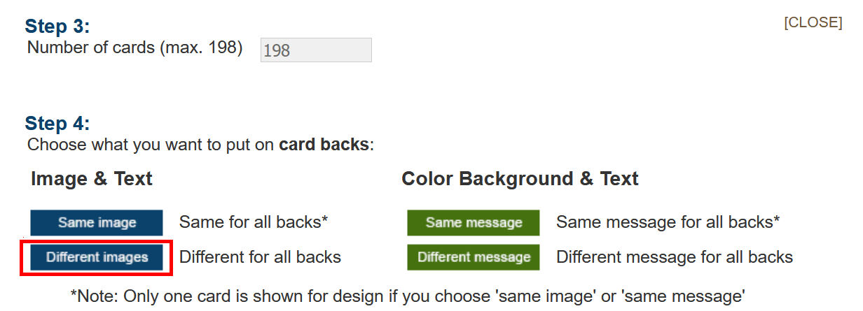

* Repeat for the back cards: click **Upload images** button, navigate to your **back** folder, select allimage files, and click **Open**. Wait until all images have been uploaded, click **Help me autofill images!** and wait until all images have been placed into the area at the left. Double-check that no blank cards left, then click **Next Step** button.

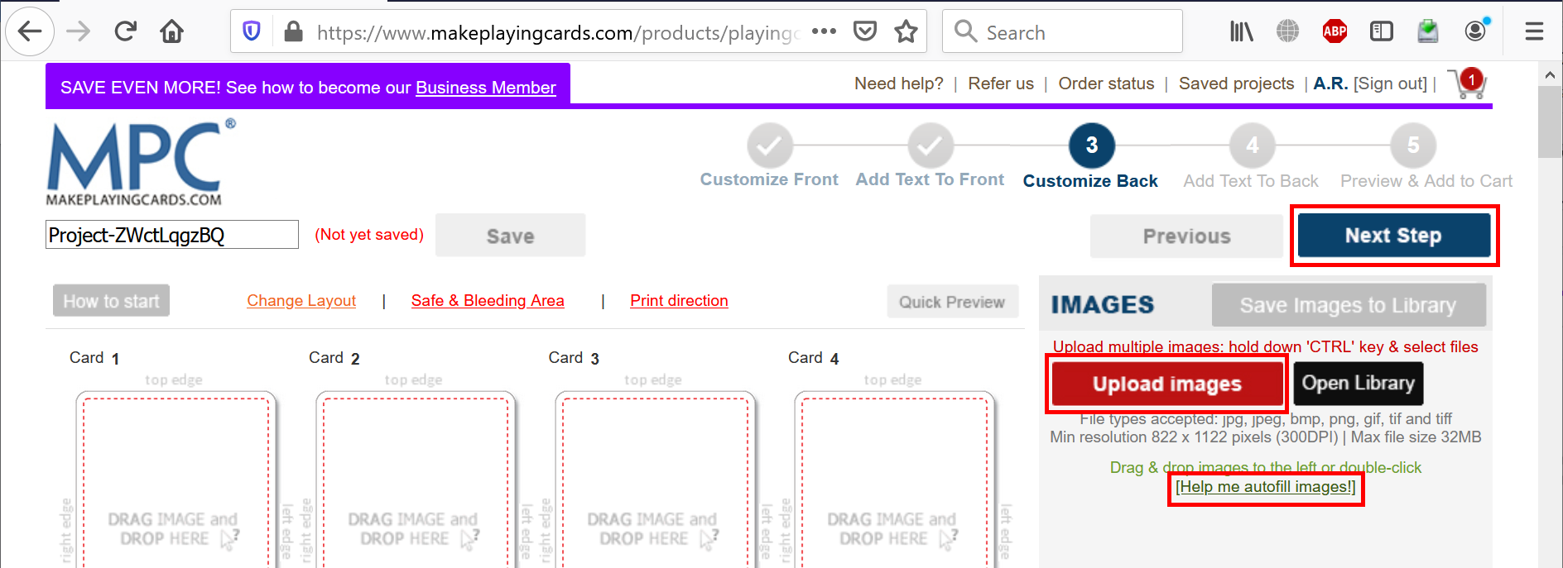

* Don’t change anything and click **Next Step** button again.

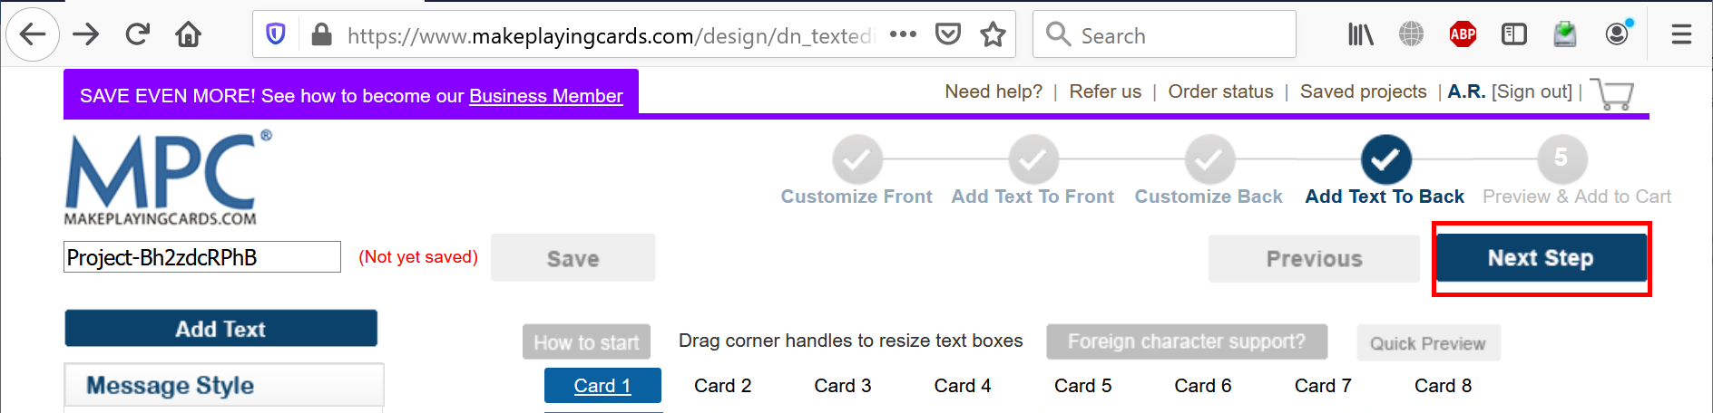

* Carefully review front and back sides of all cards. When finished, select **Yes, I confirm that all the images…** checkbox at the bottom of the page and click **Add to Cart** button.

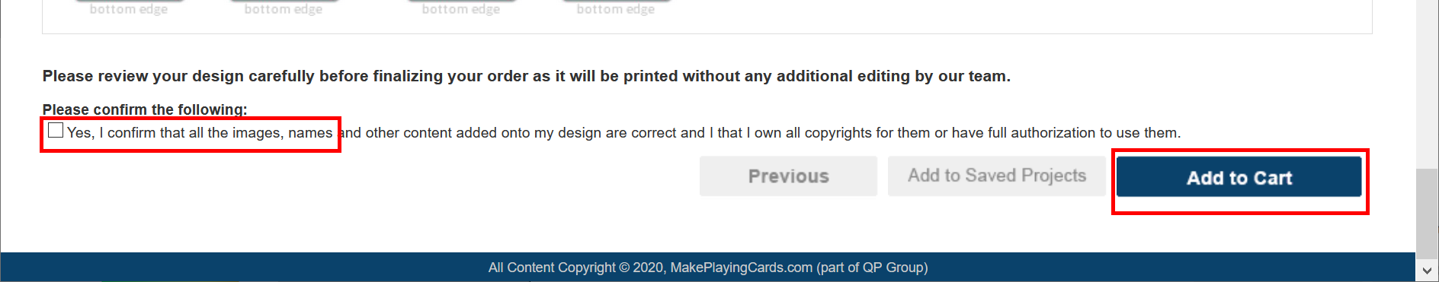

* If needed, update **Quantity**.

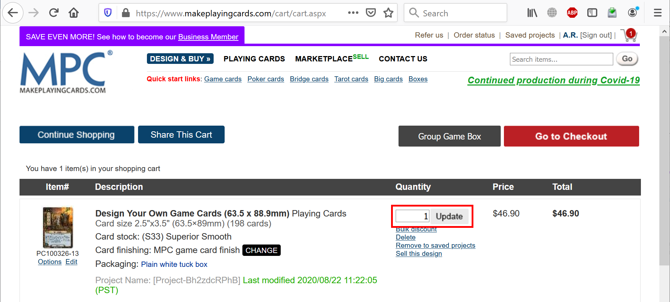

* Scroll to the bottom and click **Go to Checkout** button.

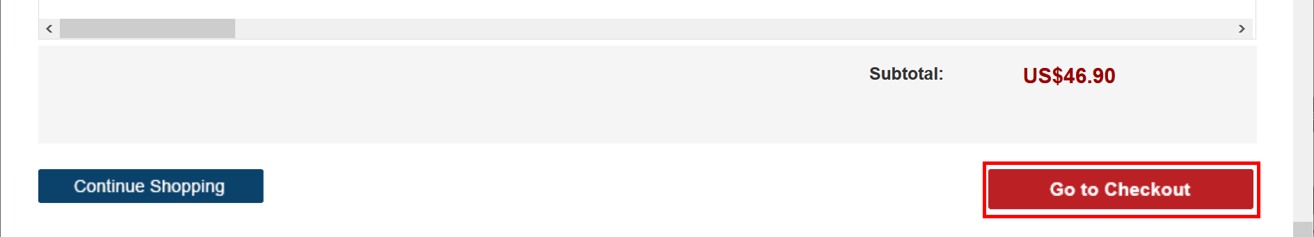

* Specify **Billing Address**, **Shipping Address**, **Shipping Method**, **Payment** details and click **Submit Order** button.

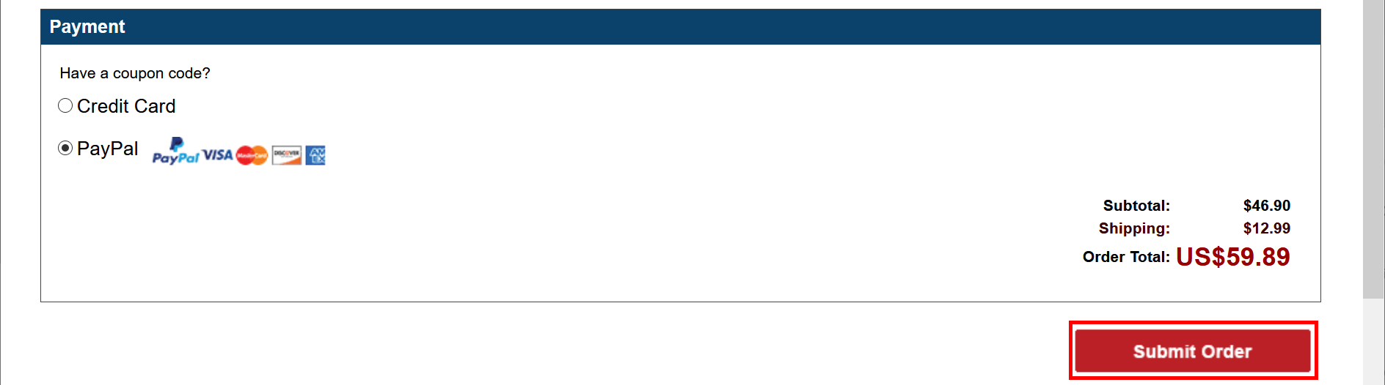

**2. Using a shared URL**

If you have a shared URL in the form **https://www.makeplayingcards.com/design/dn_temporary_parse.aspx?id=<ID>**, you don’t need to upload images manually, just follow the steps below.

* Open [**http://www.makeplayingcards.com**](http://www.makeplayingcards.com) and click **Sign In**.



* If you already have an account, enter your credentials, and click **Login** button. Otherwise, choose whether you want to **register** or just login using **Facebook** or **Google**.



* Once you logged in, open your shared URL. You will see all the cards in the shared deck.
* Carefully review front and back sides of all cards. When finished, select **Yes, I confirm that all the images…** checkbox at the bottom of the page and click **Add to Cart** button.



* If needed, update **Quantity**.



* Scroll to the bottom and click **Go to Checkout** button.



* Specify **Billing Address**, **Shipping Address**, **Shipping Method**, **Payment** details and click **Submit Order** button.



**2. Creating a new shared URL**

If you created a new deck and you want to share it, follow the steps below.

* Go to **Saved projects**.

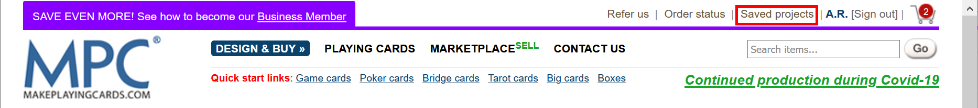

* If your deck is still in the cart and not saved to the projects yet, then either finish your order or just click **Remove to saved projects**.

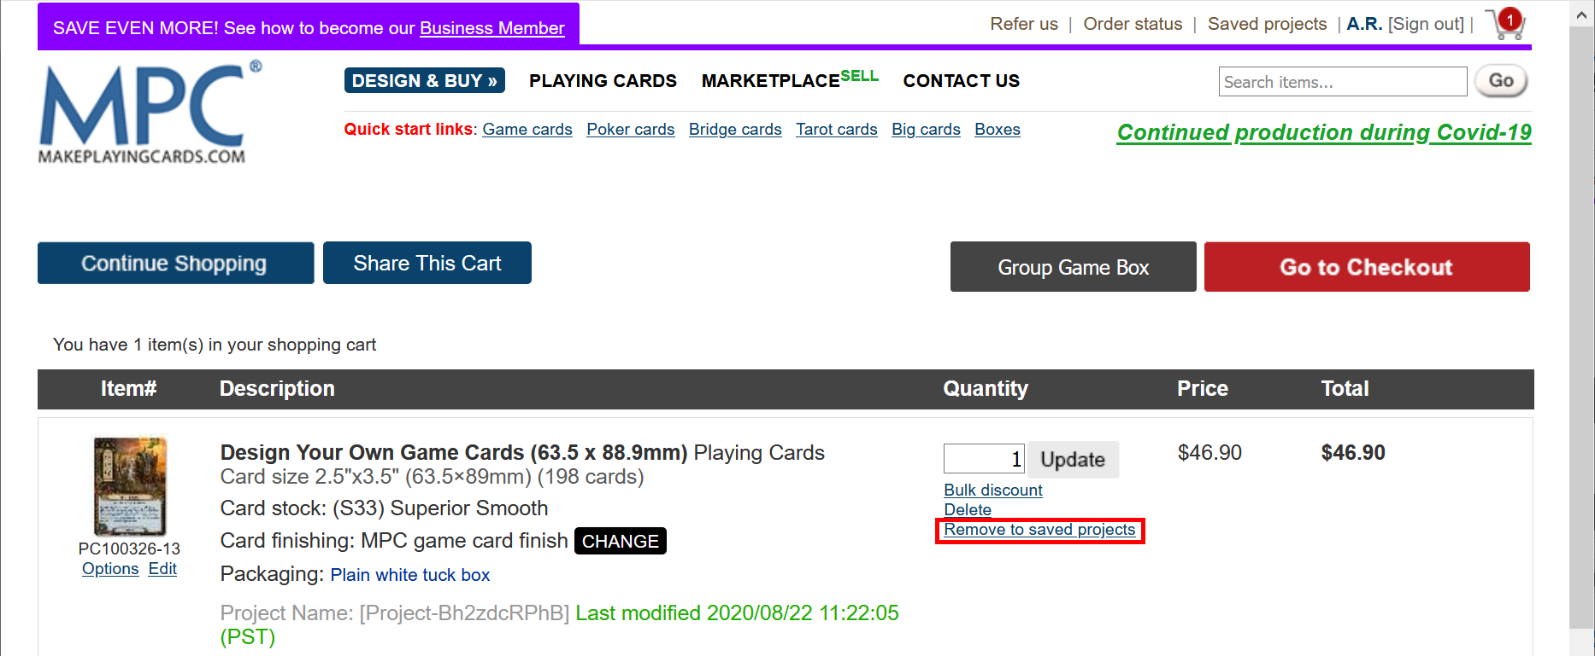

* Find the deck in the saved projects, right click the checkbox to the left of the deck and click **Inspect (Element)**.

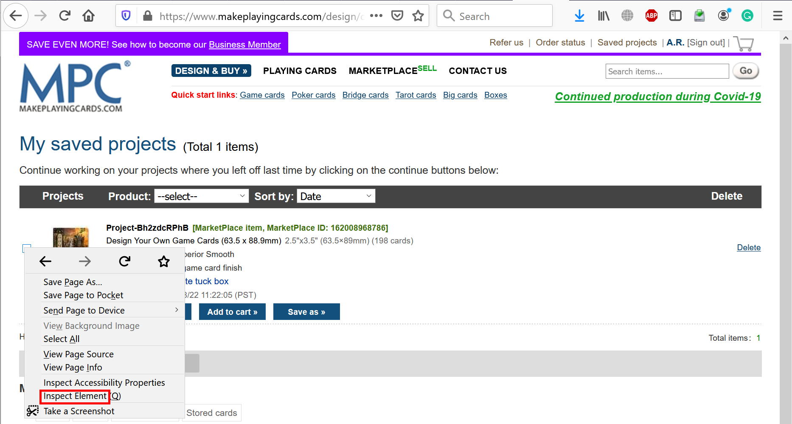

* You will see a source code. Copy a long ID of the input element (remove “chk_” prefix).

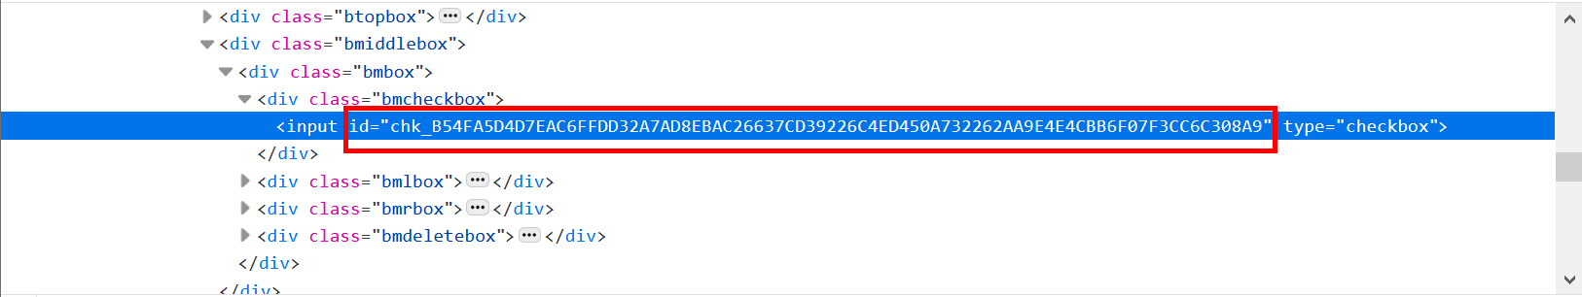

* Construct the following URL:

**https://www.makeplayingcards.com/design/dn_temporary_parse.aspx?id=<your long ID>**

* Now you can share this URL to anybody (they must be logged in).